**Simplified ERP System with React**

Name: Amit Pradeep Dhanwe

Email:amitdhanwe2310@gmail.com

Phone:+919511709789

This project is a simplified interface for an ERP (Enterprise Resource Planning) system designed to manage basic business operations efficiently. It includes features such as dashboard overview, product management, and order management.

**Table of Contents**

- Installation

- Usage

- Screenshots

- Technologies Used

**Installation**

1. Clone the repository to your local machine:

gh repo clone AmitDhanwe/Enterprise-Resource-Planning-System

2. Navigate to the project directory:

cd Enterprise-Resource-Planning-System

3. Install dependencies:

npm install

**Usage**

1. Run the development server:

npm start

2. Open your browser and visit `http://localhost:3000` to access the application.

3. Explore the different pages of the ERP system:

- Dashboard: Provides an overview of key metrics and features. You can navigate to the Products and Orders management pages from here.

- Products Management: Allows you to add, edit, and delete product listings. Displays a list of products with details such as name, category, price, and stock quantity.

- Orders Management: Facilitates viewing and handling orders. Shows a list of orders with details like order ID, customer name, order date, and status.

**Screenshots**

**Dashboard Page:**

In the dashboard, a comprehensive overview is presented, displaying the total number of products and orders within the system.

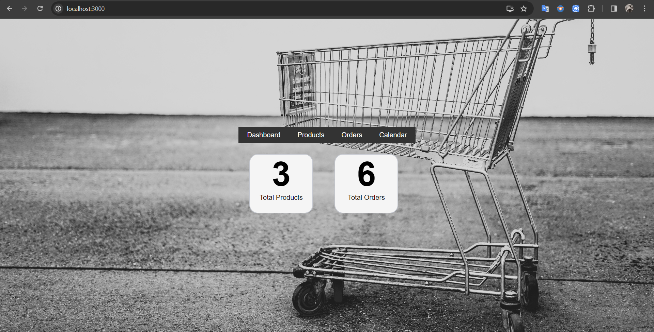

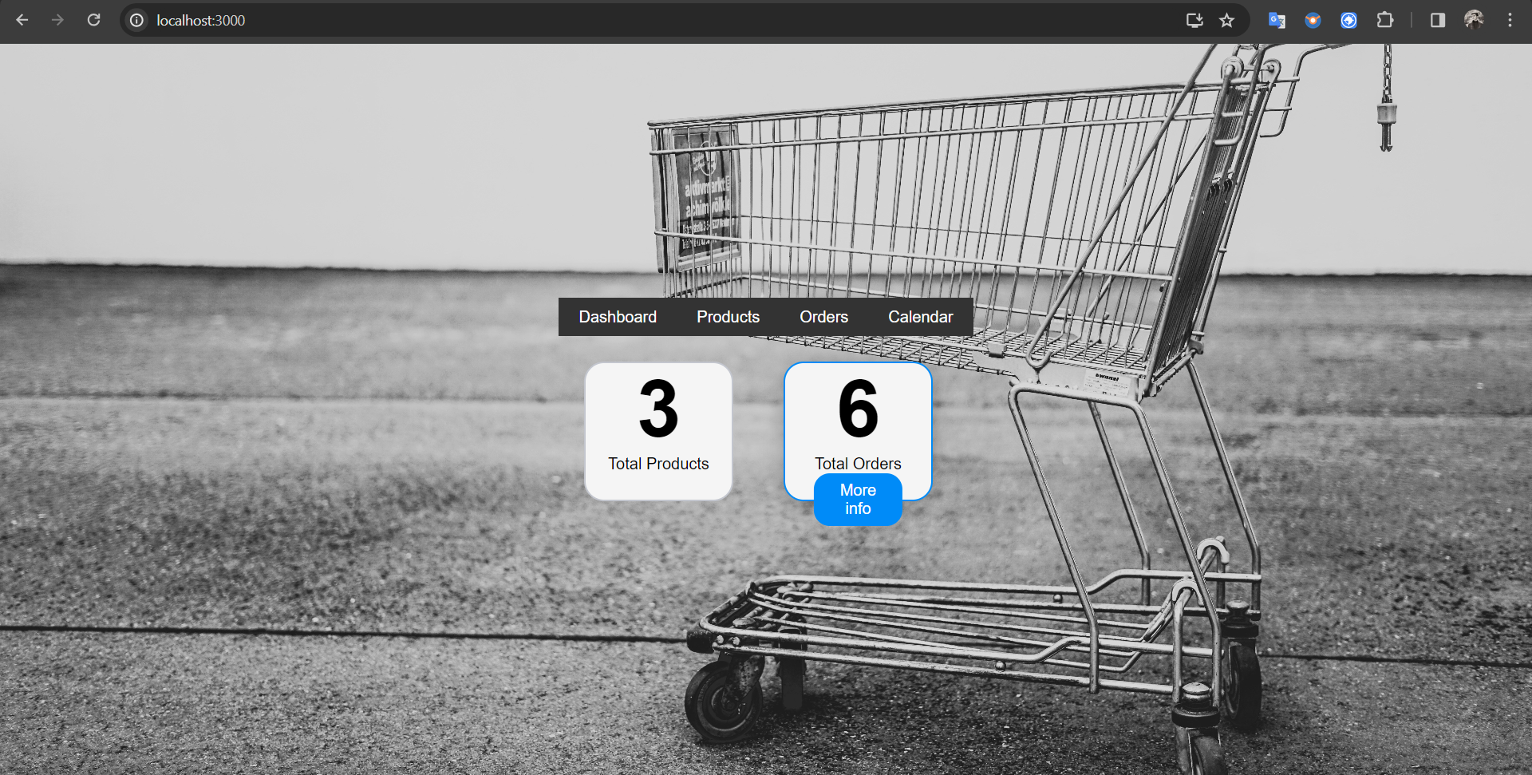

**Products Management Page:**

On the project management page, a tabulated list of products is provided, offering users the capability to seamlessly add, edit, and delete product entries.

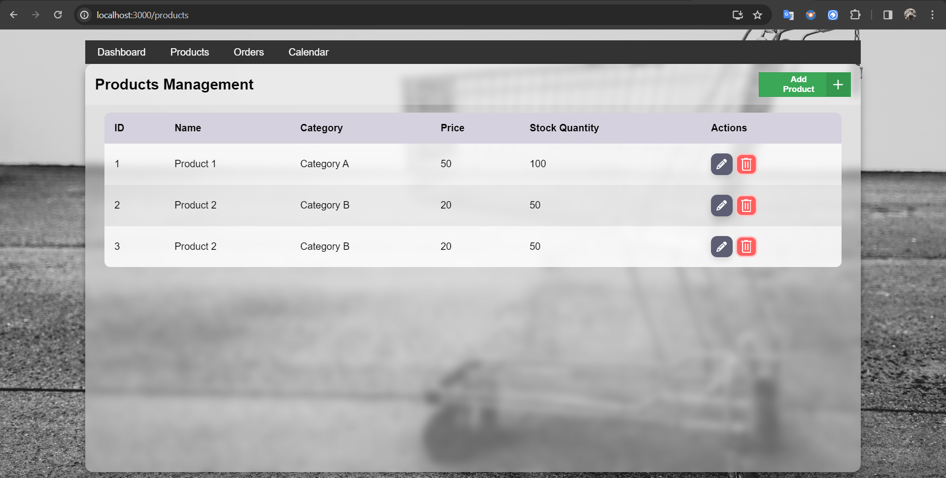

When the 'Add Product' button is clicked, a modal window appears, allowing users to input product details.

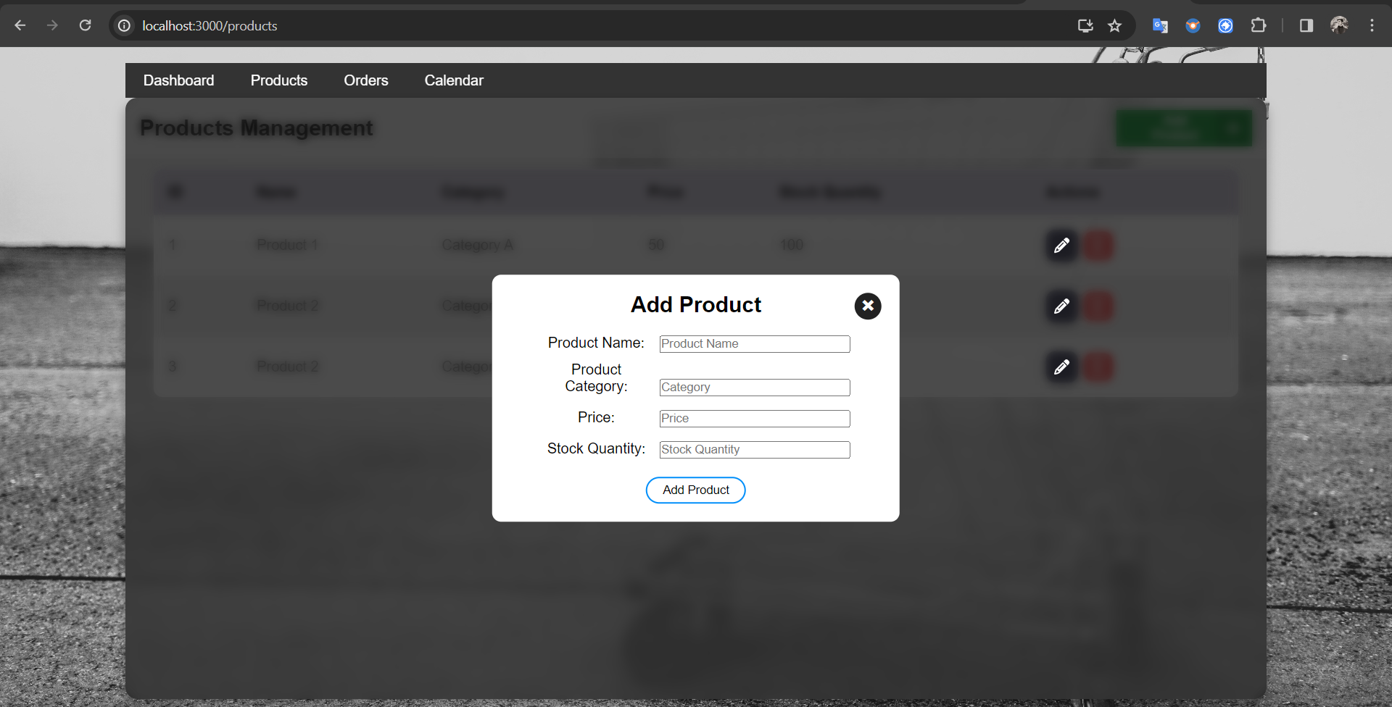

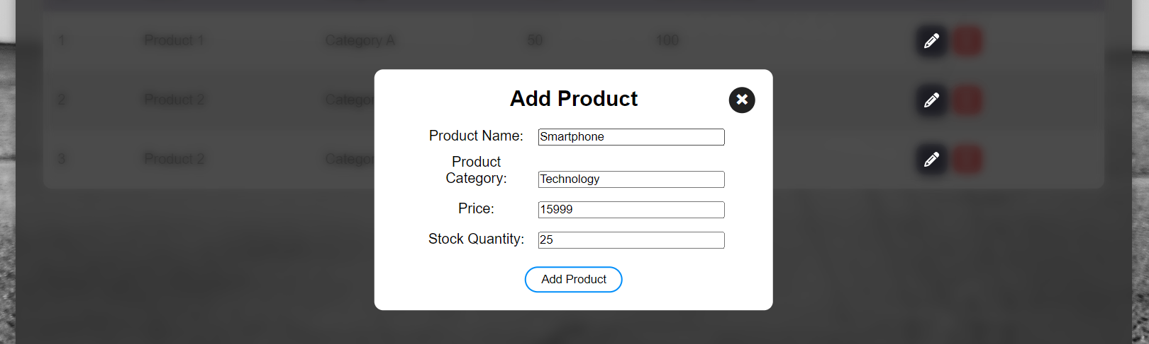

In the screenshot below, the recently added product is displayed within the table.

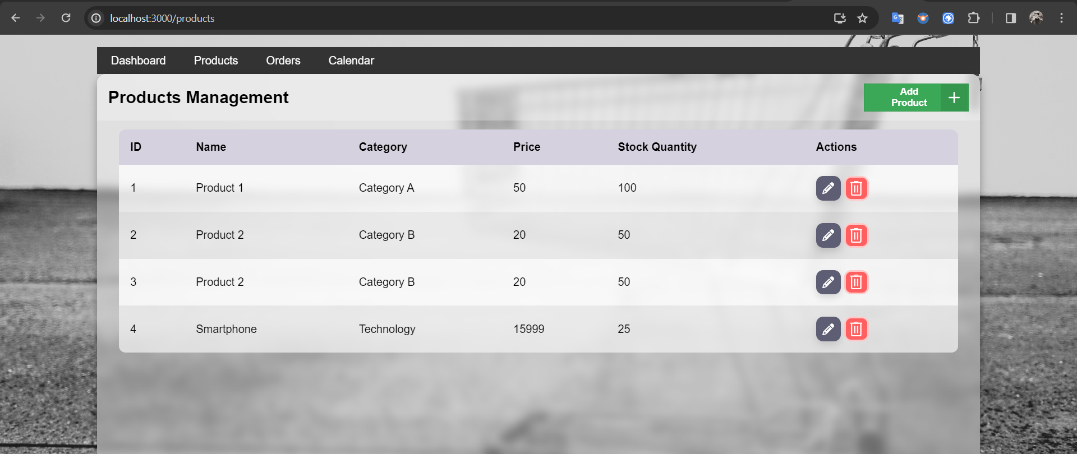

As a new product is added, the total number of products is automatically updated on the 'Dashboard' page.



After clicking the 'Edit' button, a modal window appears, presenting the product details within input fields for modification.

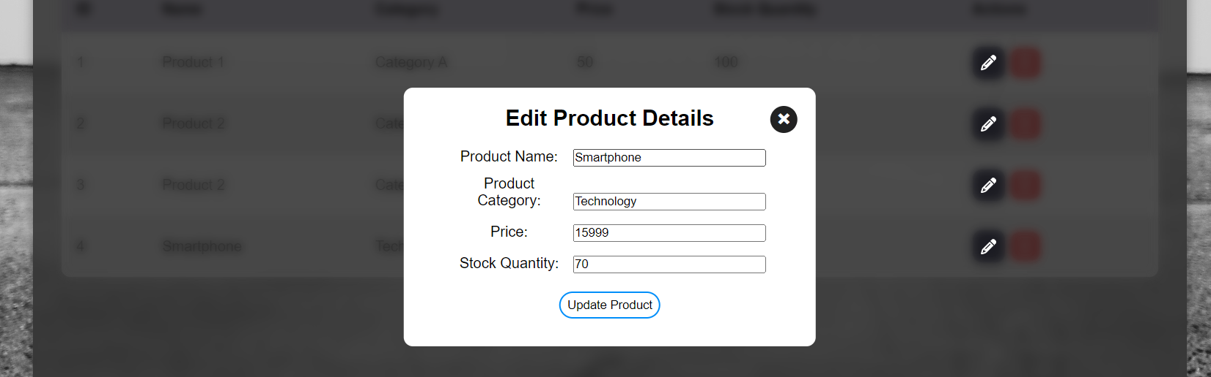

You can observe in the screenshot below that the details have been successfully updated.

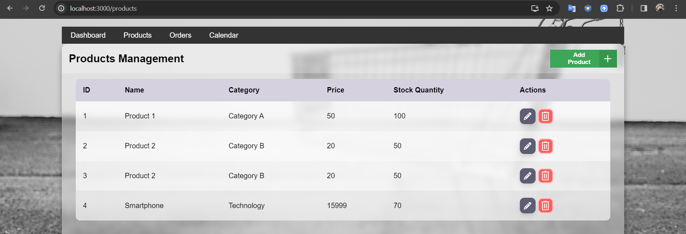

After clicking the 'Delete' button, a modal window appears, requesting confirmation along with the product ID.

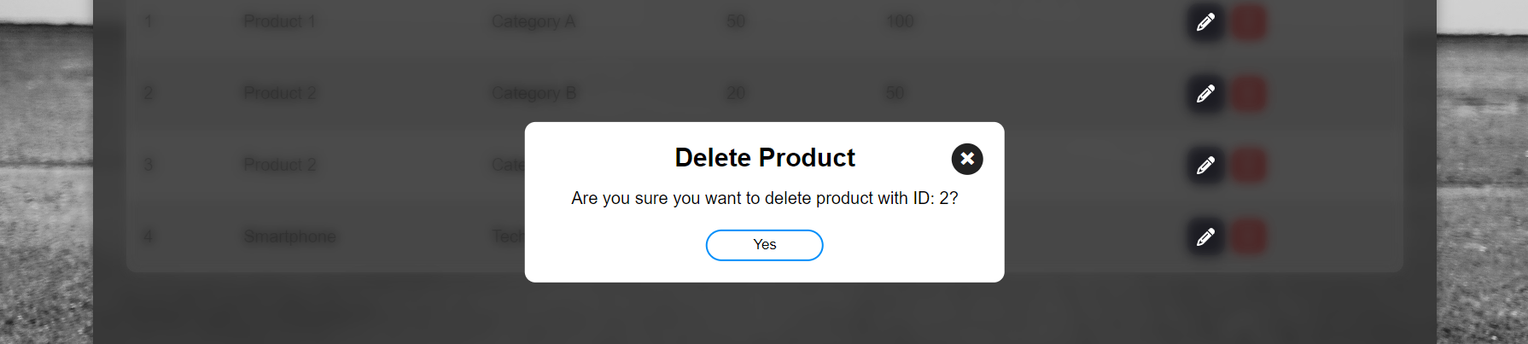

In the screenshot below, the product has been successfully deleted.

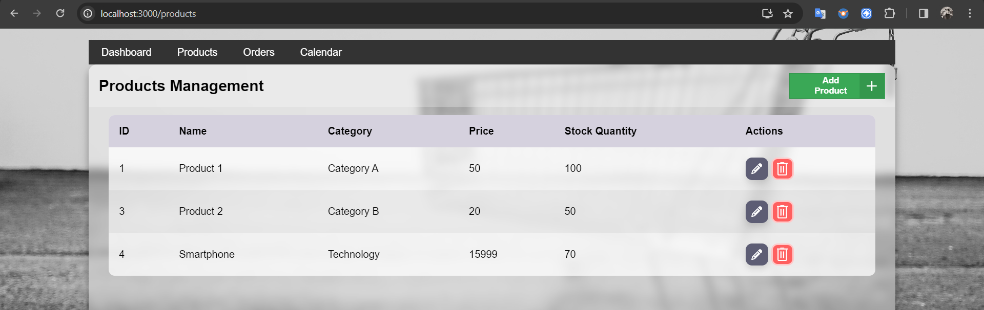

**Orders Management Page:**

On the order management page, a tabulated list of orders is presented, offering users the capability to view order details, as well as perform editing and deleting order functionalities.

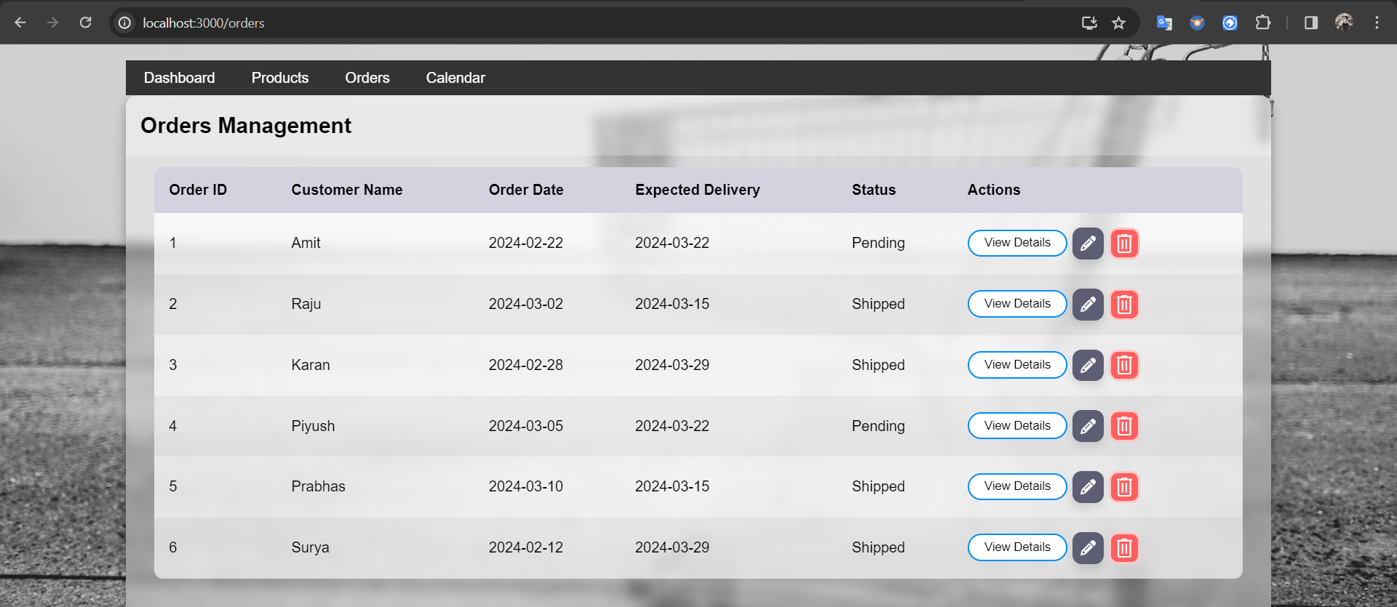

After clicking the 'View Details' button, a modal window appears, displaying the comprehensive details of the order.

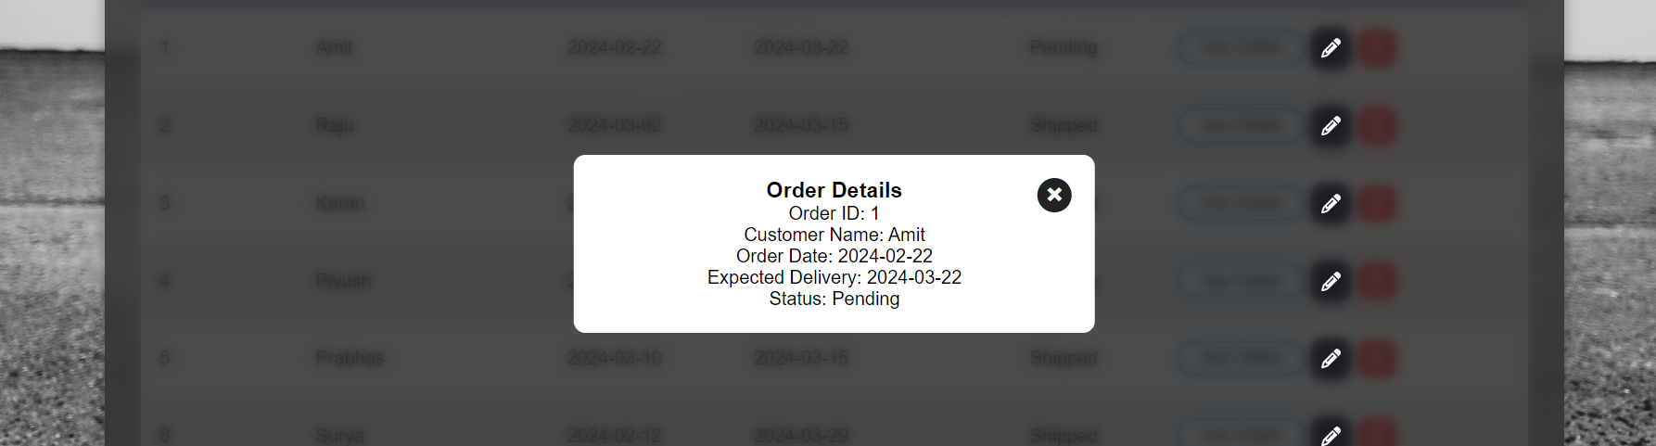

After clicking the 'Edit' button, a modal window appears, presenting the order details, allowing users to modify the expected delivery date and status of the order.

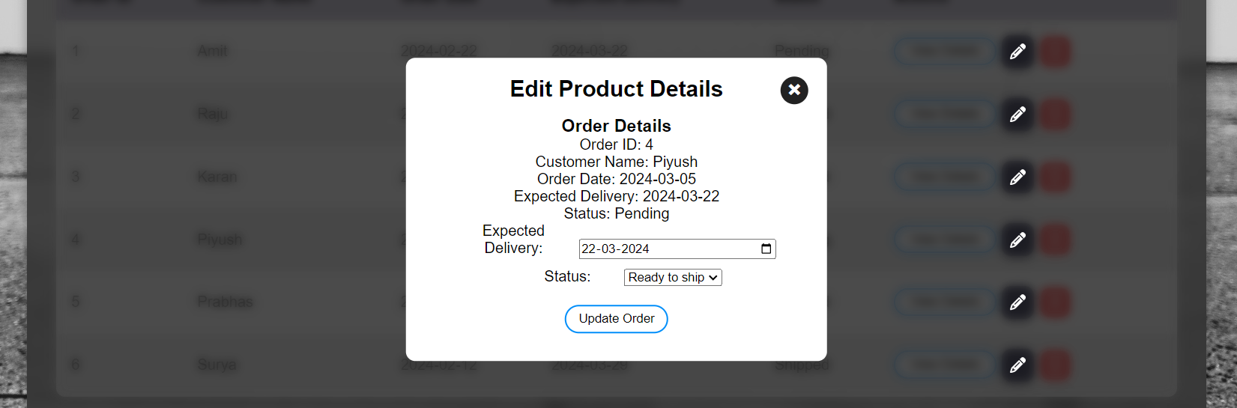

Refer to the screenshot below, illustrating the updated status of the order.

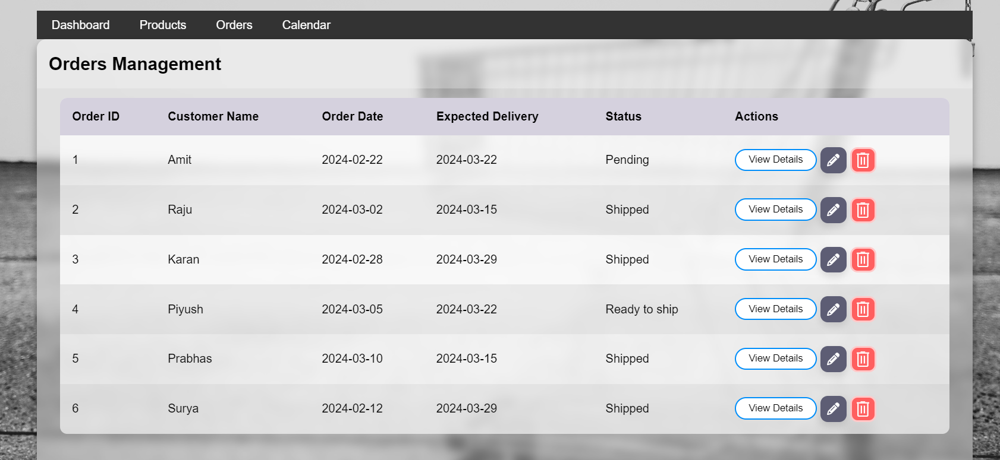

After clicking the 'Delete' button, a confirmation dialog box prompts the user, requesting confirmation along with the order ID.

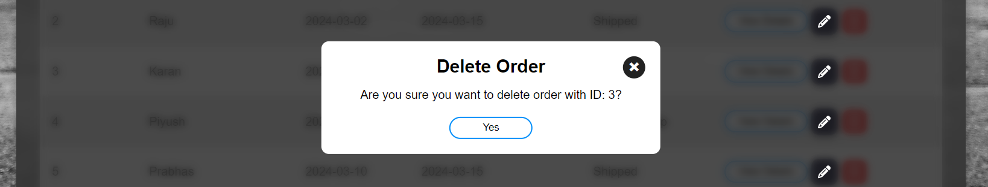

In the screenshot below, it is evident that the order has been successfully deleted.

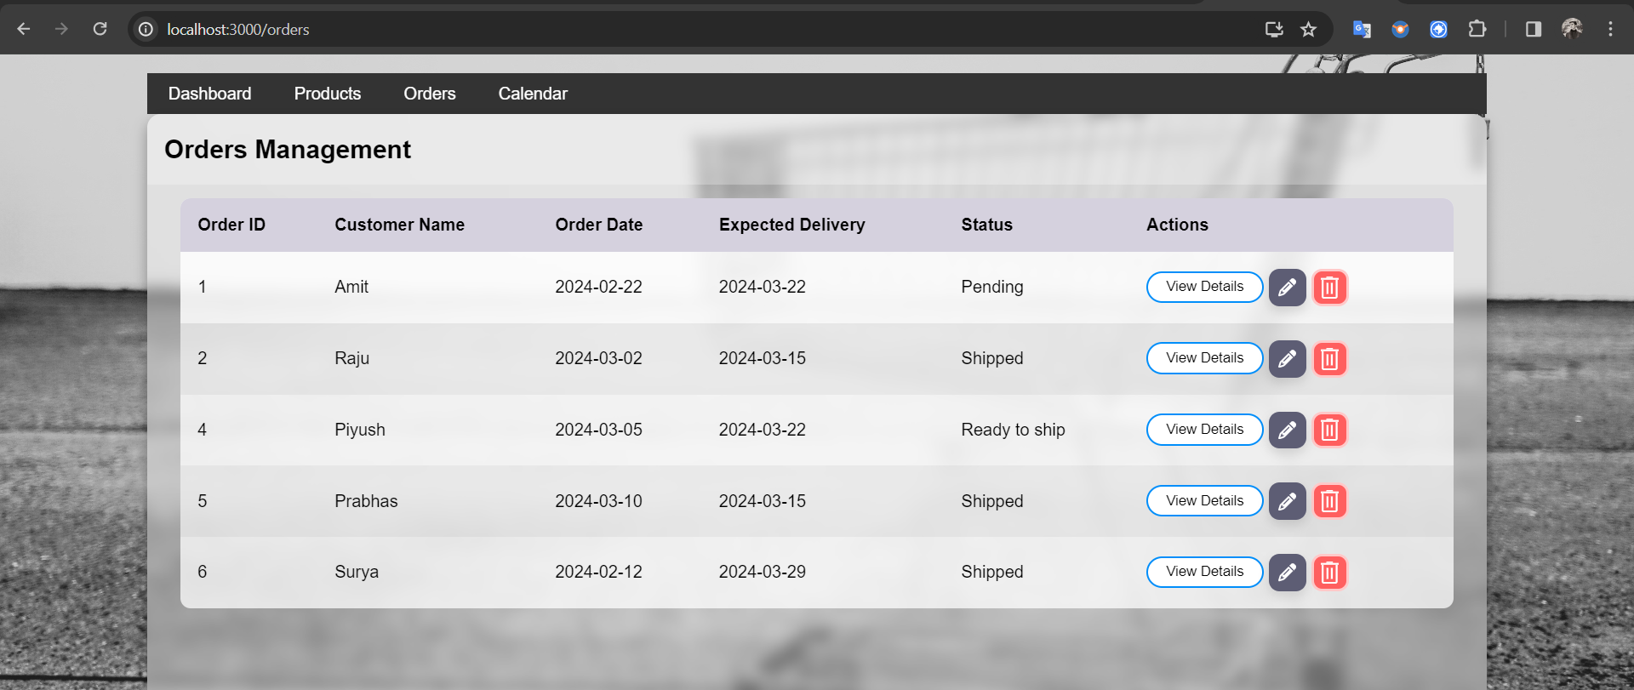

**Technologies Used**

- React

- React Router

- HTML/CSS

- JavaScript